Hack the Login
https://hackerdna.com/labs/hack-the-login
Author: Dorothy Spencer
Date: 02/12/2026
Platform: HackerDNA
Difficulty: Very Easy Level
Objective: Demonstrate and document a spoofing‑based authentication bypass to access a restricted area and retrieve the lab flag.

Click to start the machine to hack the system to find the hidden flag.
Once machine is ready click on the address provided in the lab.
For example: https://lab.hdna.me/52-hack-the-login
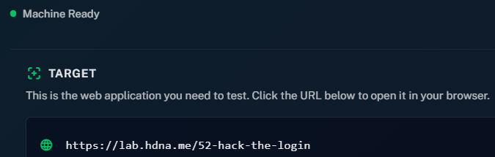
From here you should be directed to a login screen as pictured below.

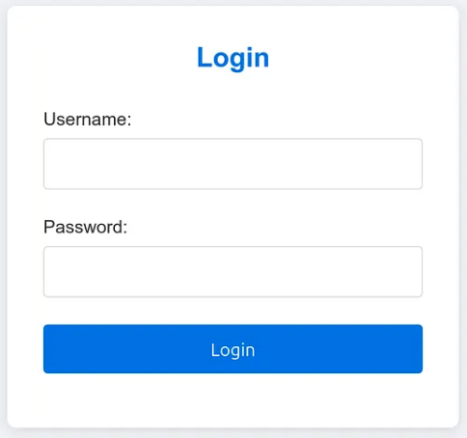
Click F12 on the keyboard < Sources < Open the script.js
Here you will see the User Name and Password as well as the Flag.txt code
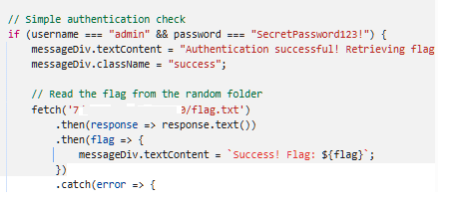
Log into the site with the found credentials.
Username: admin
Password: Found in script when you locate it in the script.js file
Click the Login Button
Page will come up to insert the flag is found.
Click Submit

